| **Name : Yash Sarang** | **Class/Roll No. : 47** | **Grade :** |
| --- | --- | --- |

**Title of Experiment :** Creation of Scenario: Write a scenario that involves all three of the tasks identified for the chosen project.

**Objective of Experiment :** The objective of this practical is to create a scenario that explore various conversations between individuals discussing different aspects of cab booking services.

**Outcome of Experiment :** Thus, we created 3 different scenarios depicting the key features of the application.

**Problem Statement :** The aim is to develop a 3 scenario that encompasses the features of the booking application.

**Description / Theory :**

Scenario creation is a vital aspect of the user interface (UI) and user experience (UX) design process. It involves crafting detailed narratives that depict how users will interact with a product or system. These scenarios are invaluable tools for designers, as they help in understanding user needs, behavior, and expectations.

By meticulously outlining the user’s journey, scenario creation enables designers to anticipate potential pain points, identify opportunities for improvement, and tailor their designs to meet user preferences. These narratives serve as a bridge between design concepts and real – world user interactions, facilitating more informed decision – making throughout the design process

Scenarios are created in UI / UX design for several key reasons:

* Understanding Users: Scenarios help designers empathize with users by depicting their needs, motivations, and behaviors.
* Design Guidance: They provide a clear vision of how users will interact with a product, guiding the design process.
* Usability Testing: Scenarios serve as test cases to evaluate a product’s usability and gather user feedback.
* Alignment with Business Goals: They ensure that user interactions contribute to achieving the product’s broader objectives.

**Scenario:**

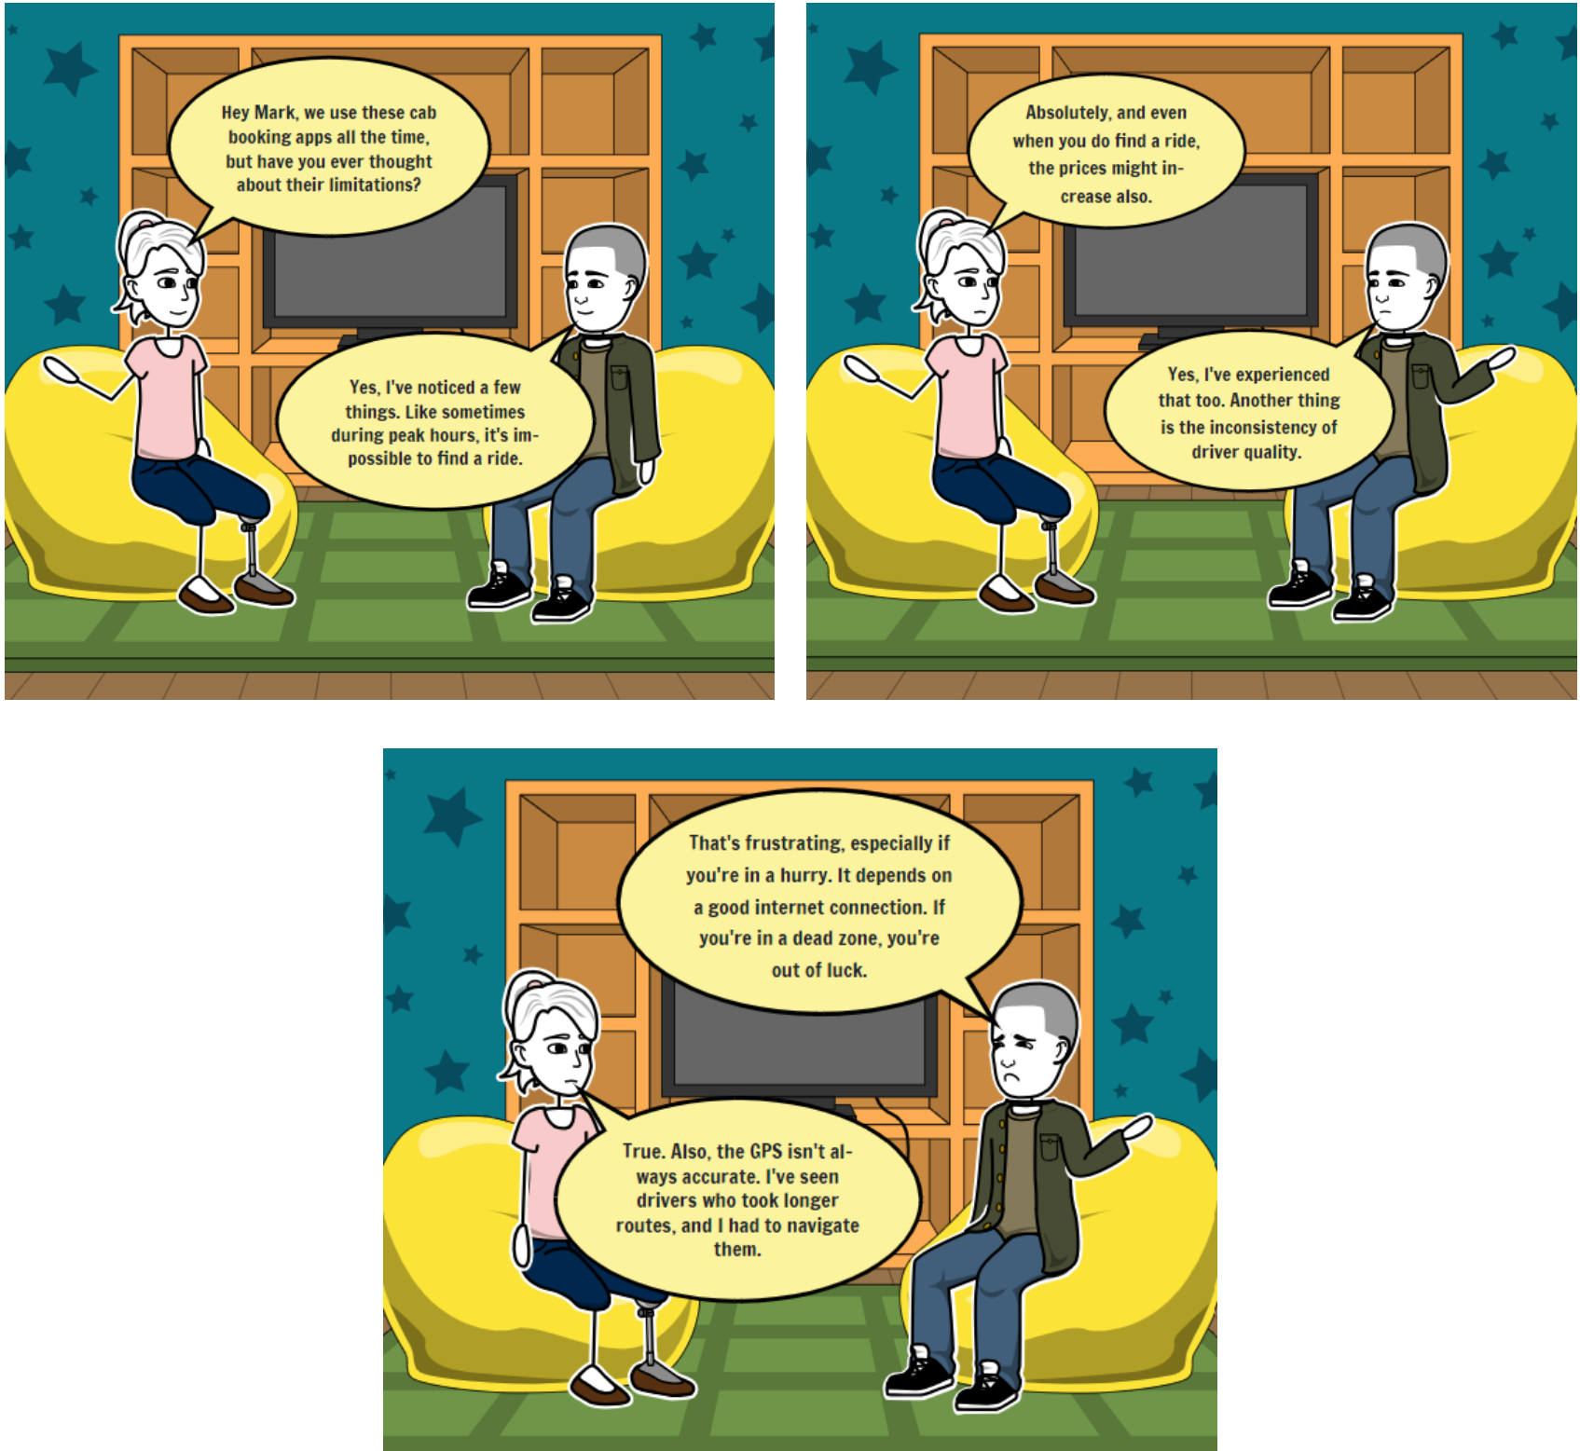

**Results and Discussions :**

The scenario highlights the seamless integration of the three identified tasks in the online pharmacy system. Sarah's experience showcases the patient-centric approach, enabling a swift and convenient medication ordering process. The doctor's involvement in prescription verification ensures medical accuracy and safety. Simultaneously, the pharmacist's role in medication dispensing and inventory management ensures operational efficiency. This scenario underscores the importance of a well-designed online platform that caters to patients, doctors, and pharmacists, streamlining the medication procurement process while prioritizing accuracy, safety, and user satisfaction. **\*\*\*\*\***